**PROPERTY MANAGEMENT APPLICATION**

**USING SALESFORCE**

1. INTRODUCTION

1.1 OVERVIEW

Property management is the daily oversight of residential, commercial, or industrial real estate by a third-party contractor. Generally, property managers take responsibility for day-to-day repairs and ongoing maintenance, security, and upkeep of properties. They usually work for the owners of investment properties such as apartment and condominium complexes, private home communities, shopping centers, and industrial parks. Their main roles are to manage routine tasks delegated to them by the owners and to preserve the value of the properties that they manage while generating income.

1.2 PURPOSE

* The roles property managers play in managing your real estate property is a vital one. Hiring a property management company to handle your real estate can significantly increase the value of your investments in a short period. A property expert knows the industry and has experience navigating the market. This way they help you avoid making silly mistakes that can ruin your investment.
* With a property management company handling your real estate, you get to have more time to manage some of the other investments.

2. PROBLEM DEFINITION & DESIGN THINKING

2.1 Empathy Map

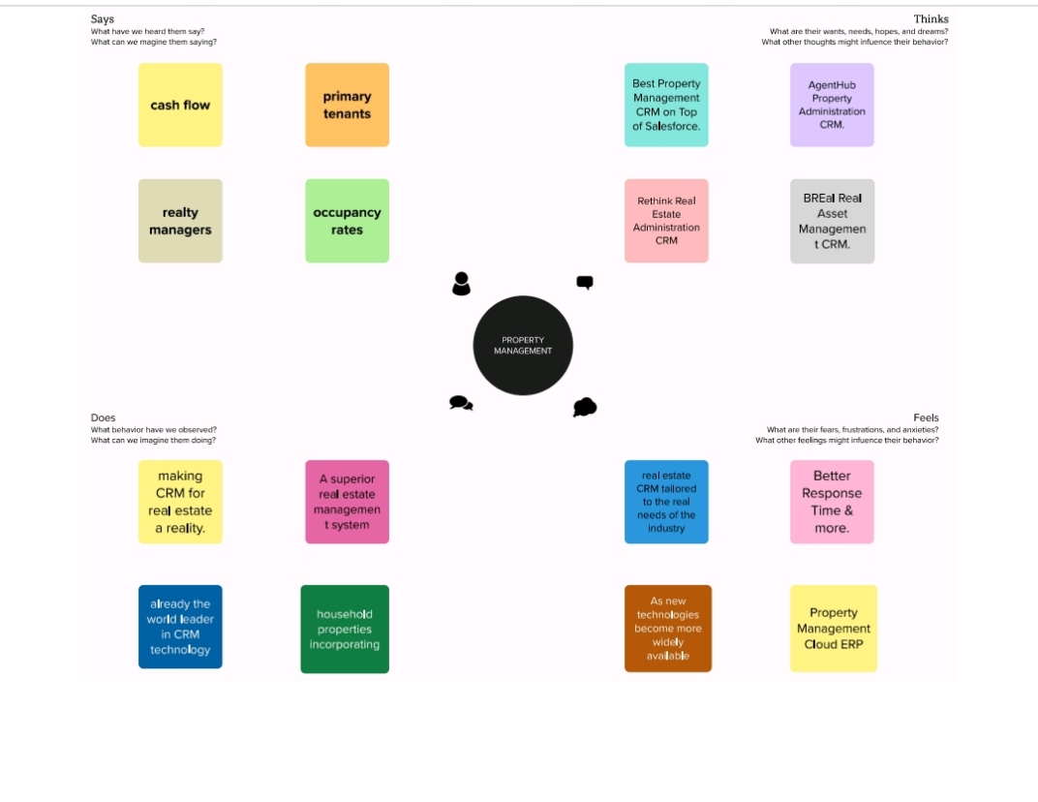

2.2 IDEATION & BRAINSTROM MAP

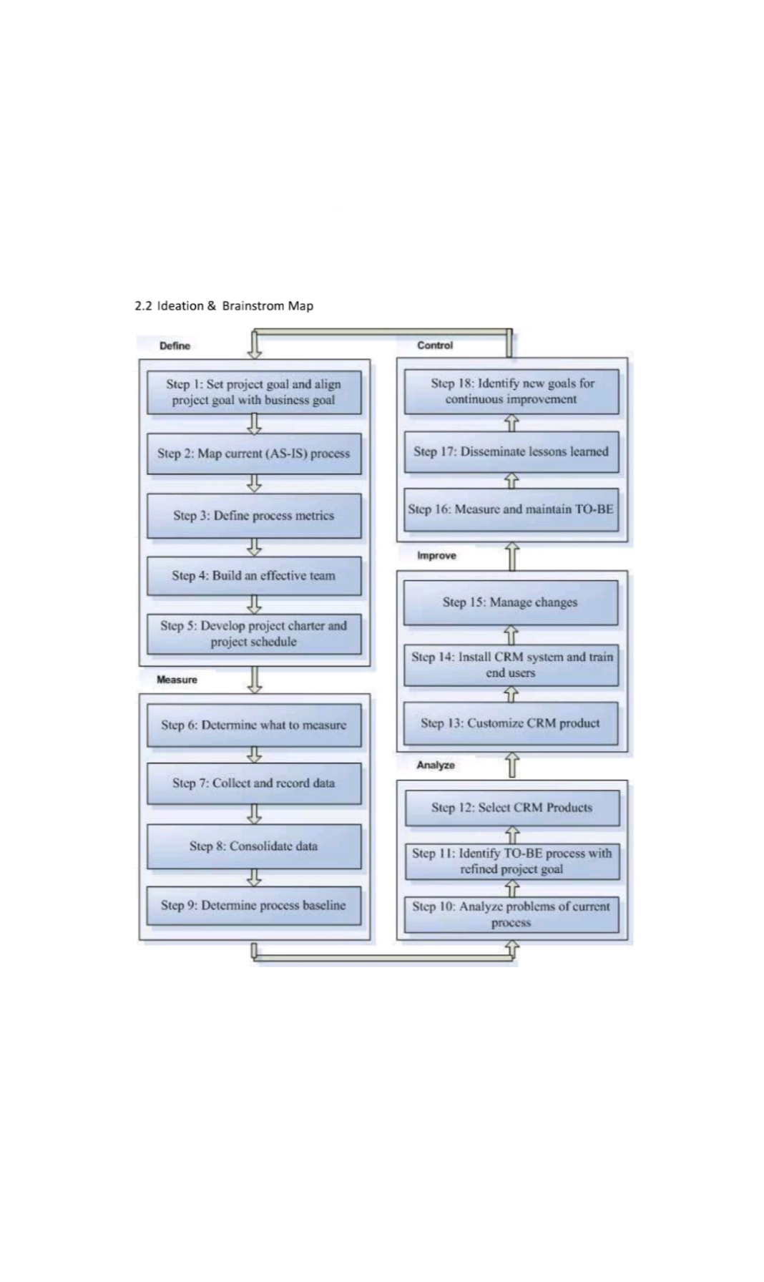

3. RESULT

3.1 Data Model

* OBJECT NAME ___ FIELDS IN THE OBJECT

1. BUY - FIELD LABEL __ DATA TYPE

CANDIDATE NAME - TEXT

COURSE ID - TEXT

BUY NAME - TEXT

MARKS - NUMBERS

2. LEAD - COURSE - LOOKUP

COURSE ID - TEXT

LEAD NAME - TEXT

LEAD ROLE - TEXT

3. LOAN - LOAN - TEXT

LOAN - LOOKUP

LOAN NAME - TEXT

4. RENT - RENT - LOOKUP

RENT NAME - TEXT

RENT ID - TEXT

SEMESTER NAME - TEXT

3.2 ACTIVITY & SCREENSHOT

* HOME PAGE OF SALESFORCE ACCOUNT

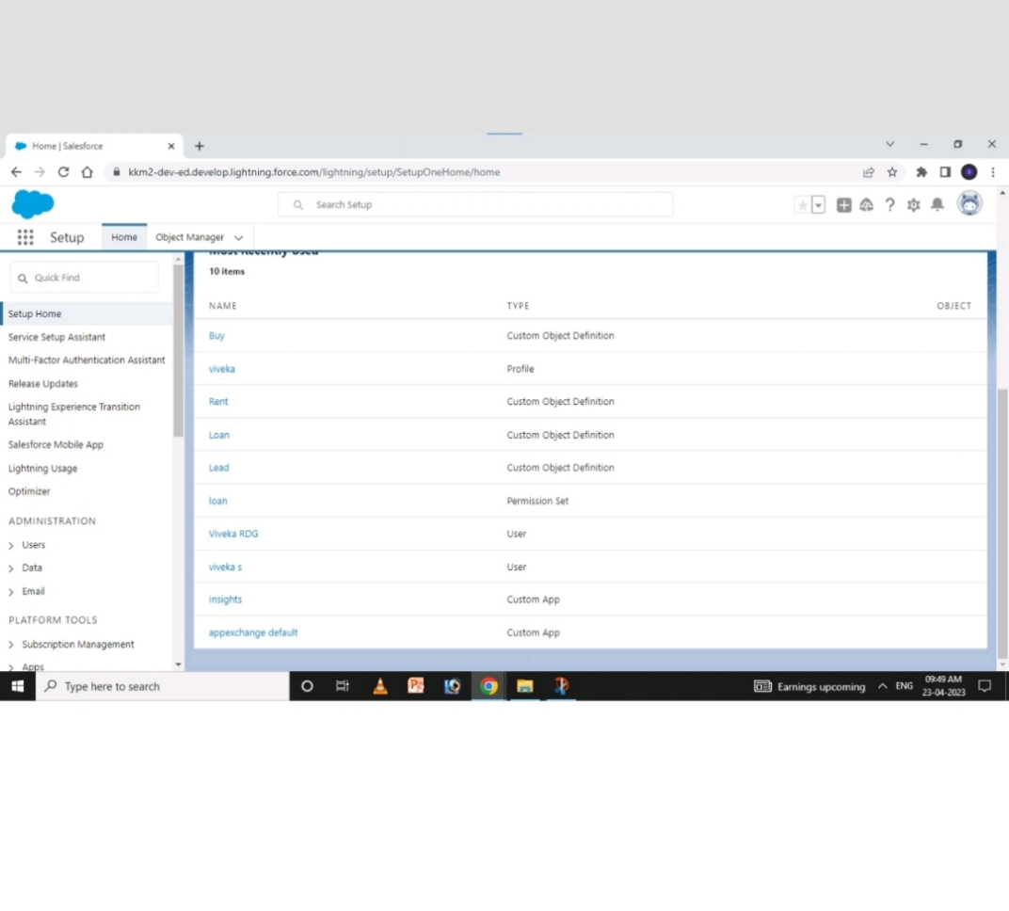

* CUSTOM OBJECTS
* BUY

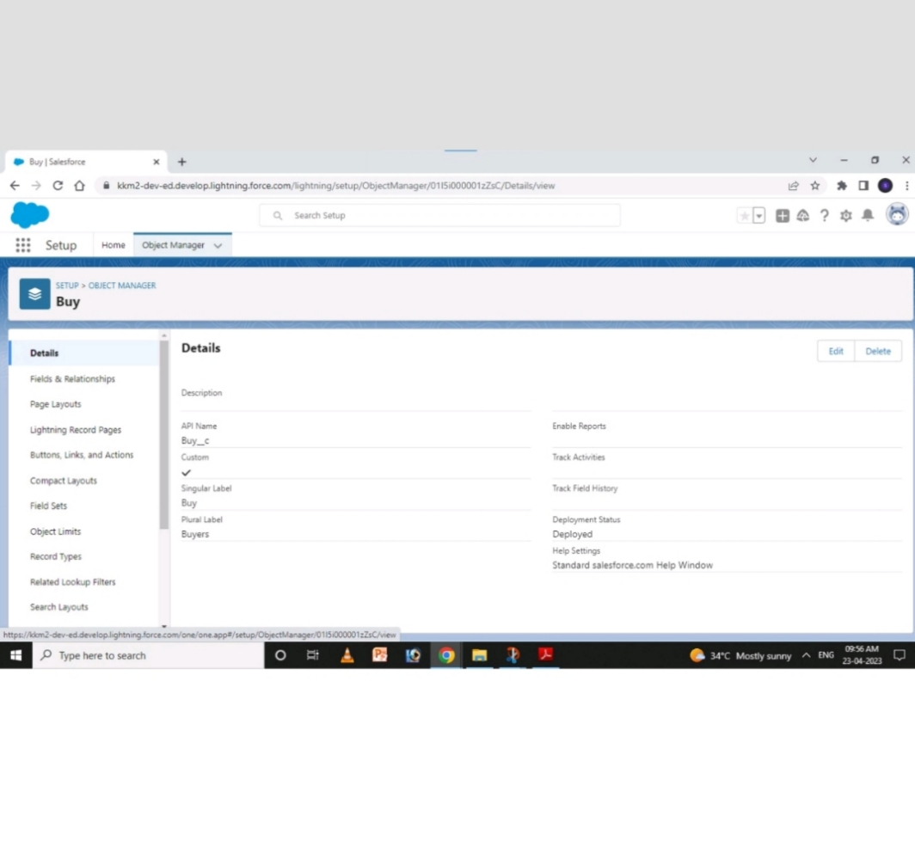

* LEAD

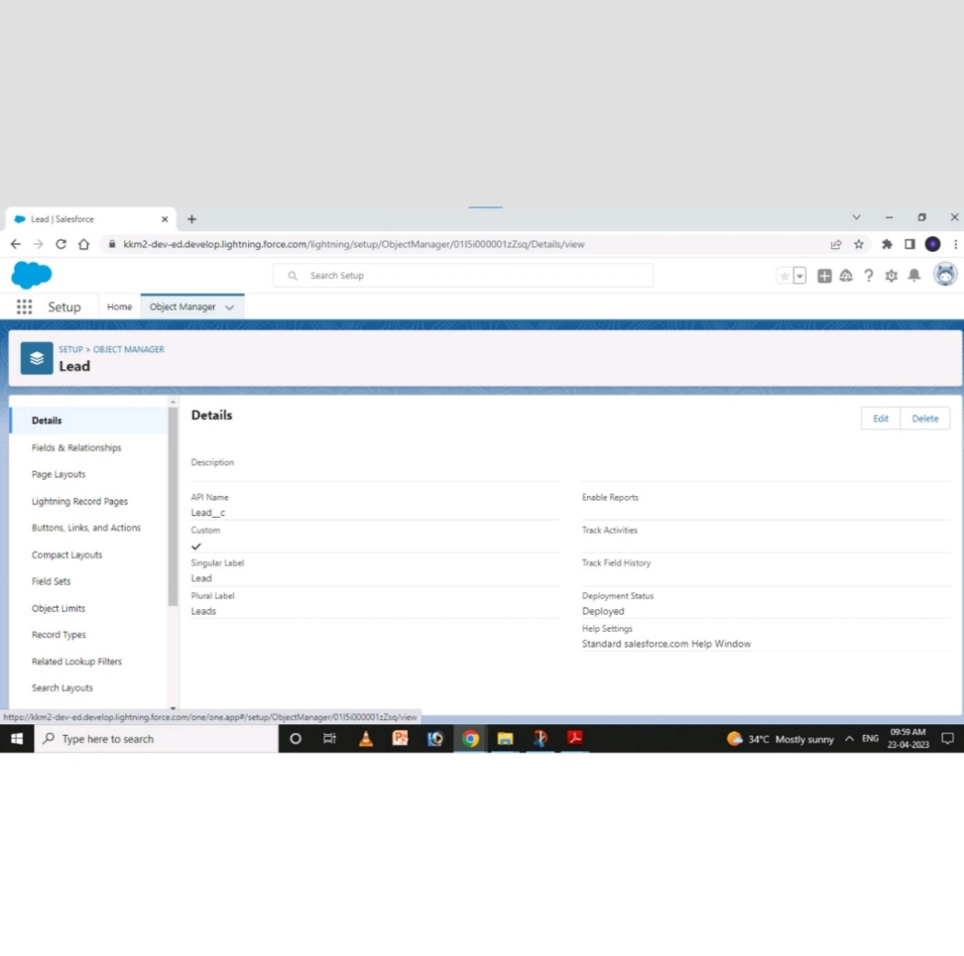

* LOAN

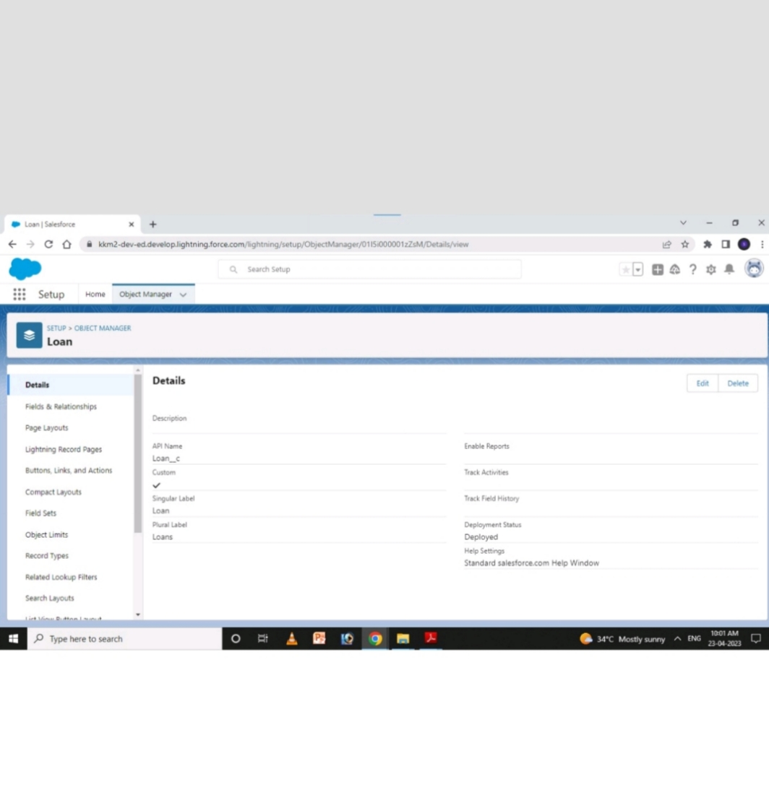

* RENT

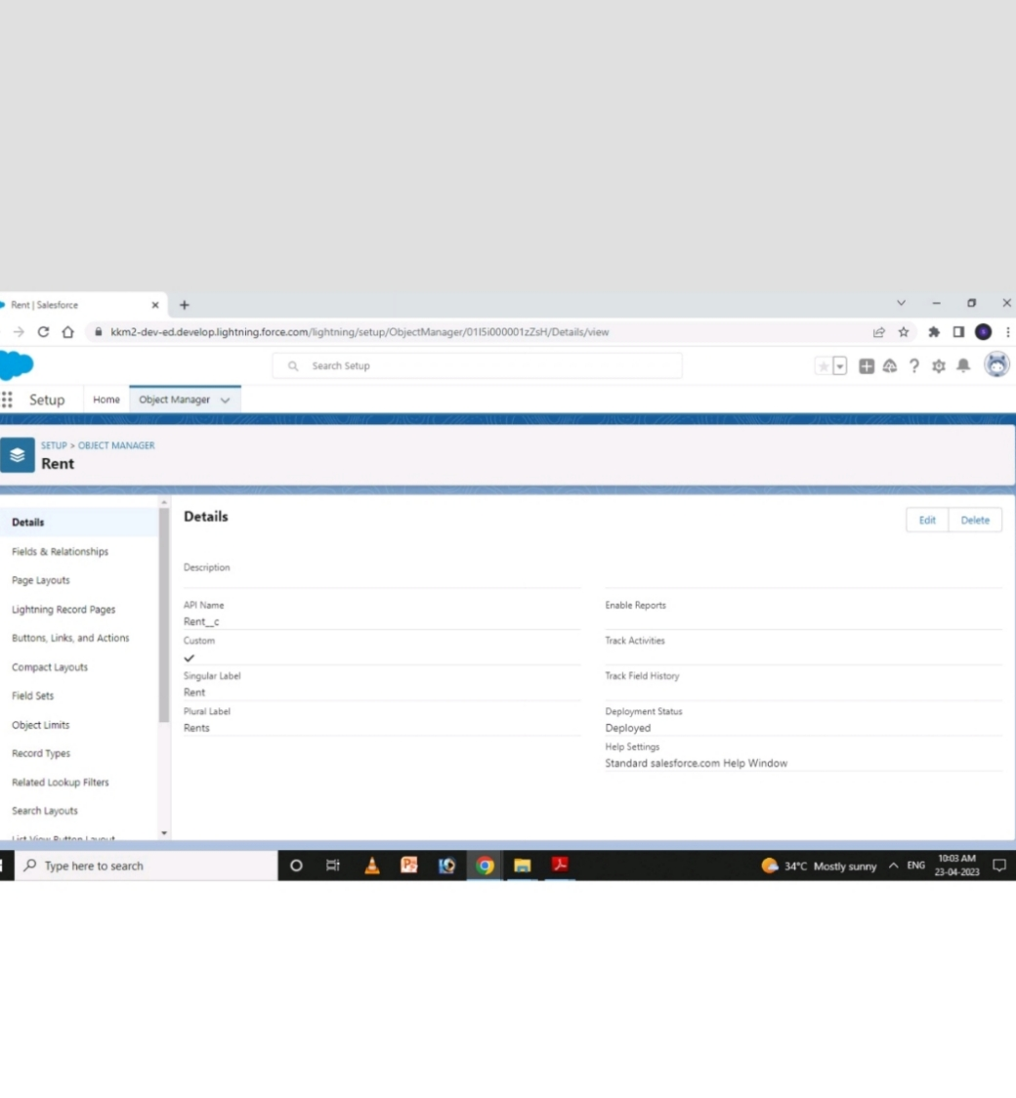

* USERS

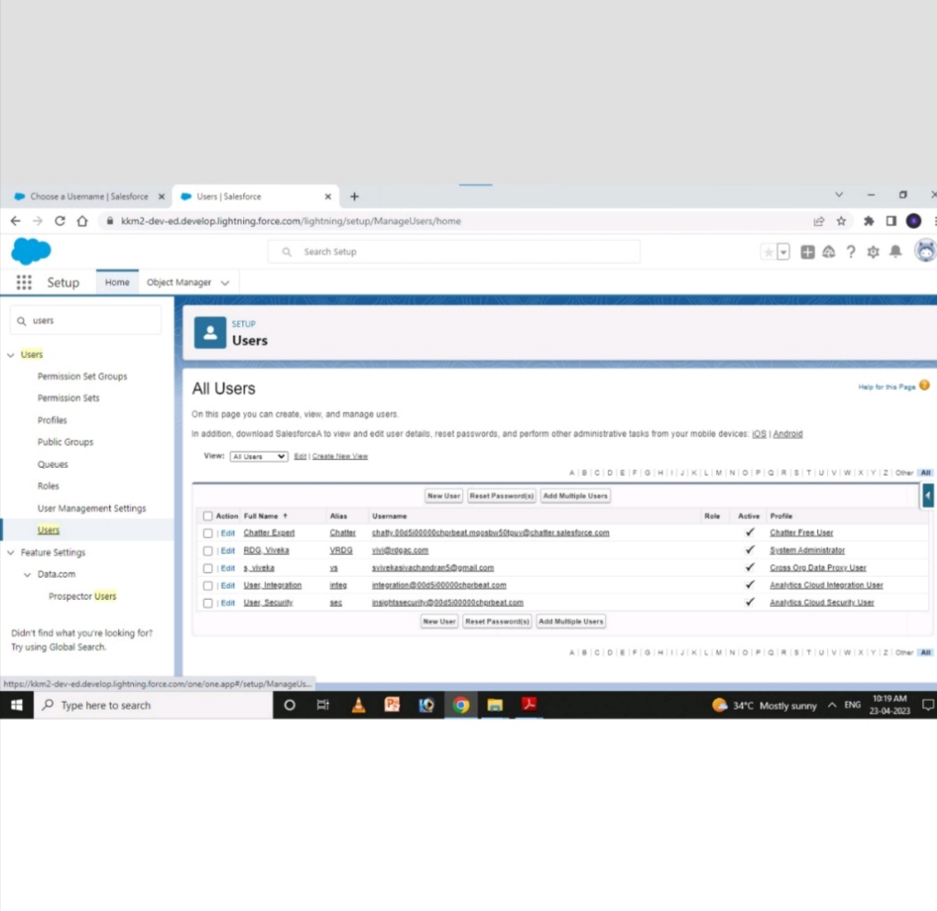

* REPORTS

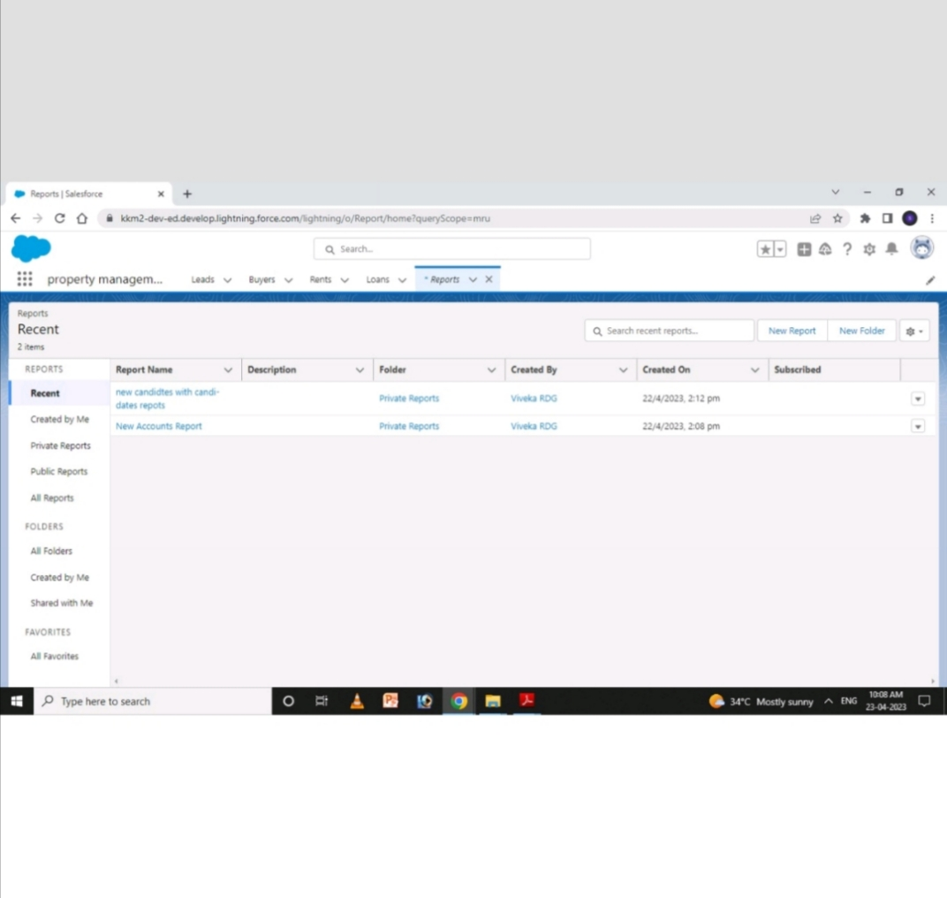

* DASHBOARD

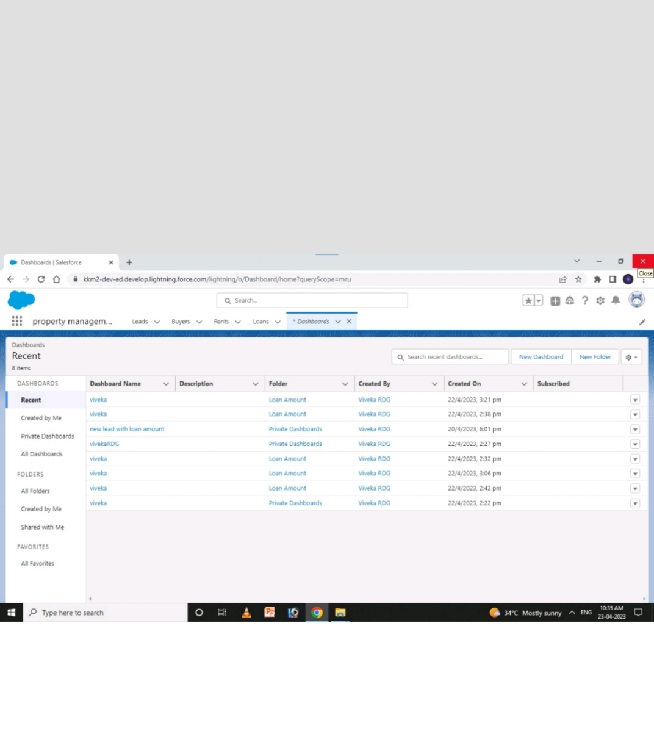

4. TRAILHEAD PROFILE PUBLIC URL

## TEAM LEADER -https://trailblazer.me/id

## TEAM MEMBER 1 -https://trailblazer.me/id/ssivachandran

## TEAM MEMBER 2 -https://github.com/

## TEAM MEMBER 3 -https://trailblazer.me/id/ykannan2

## TEAM MEMBER 4 -https://trailblazer.me/id/mpriya209

ADVANTAGES

1. High quality tenants

2. Less legal problems

3. Shorter periods of vacancy

4. Long term tenants

DISADVANTAGES

1. Time consuming if you choose the wrong system

2. Might seem expensive for a small business

3. Training (cost and time)

APPLICATION

* In this tutorial, we will take a look at the property management application which we build in this course. We will learn about the custom object which we will create for our property management application. We will also learn about integrating authorize. Net payment gateway system with sales force in order to process the payments made by our renter.

CONCLUSION

* In conclusion, property management system software is very crucial for all the hotels. Especially opera PMS constitutes the most appropriate PMS software for Hilton Athens. It is user friendly, connects with central reservation system, point of sale etc. and provides all the tools the hotel needs in order to operate effectively. The disadvantages of the opera PMS can be improved easily and as it was mentioned before a recommendation is the upgrade of opera V5 to opera 9.

FEATURE SCOPE

* Reservation
* Front desk operations and room management
* Channel management integration
* Direct distribution via booking engine
* Mobile apps
* Marketing support
* CRM & guest communication
* Reports and analytics